igus extends world's largest lead screw shop with new nut material
Lubrication-free lead screw nuts made of iglidur J200 extend service life three-fold

With the new durable material iglidur J200, igus expands its largest range of lead screw systems in the catalogue and online. The advantage of the online shop: Configure high helix, trapezoidal and metric threads online with the lead screw configurator and predict the service life of the nut. In addition to the three common lead screw materials, depending on requirements, the designer can choose from nine different lubrication-free and maintenance-free nut materials. This now includes the high-performance iglidur J200 material with superior wear-resistant properties.

Adjustable lead screw drive systems for fast or slow positioning. They convert rotational motion into a linear movement. igus self-lubricating lead screw drives are used in a wide range of applications, including extendable platform steps on commuter trains, 3D printers and valve actuators and fittings in the chemical and process engineering sectors. To address these diverse functions, the engineer can configure their design online in the igus lead screw configurator (www.igus.eu/leadscrewshop), choosing from a wide variety of drive systems and technologies. In addition to metric threads, trapezoidal and high helix lead screw threads are available. The latter can replace toothed belt or pneumatic drives. With more than 70 different lead screw pitches, 3 lead screw materials and 9 different nut materials – such as the new durable iglidur J200 – in 10 different versions, igus offers the widest selection worldwide with more than 5,000 lead screw combinations. In addition to ordering online, the igus lead screw shop enables the engineer to calculate the expected service life of the drive system. Another online tool is the lead screw configurator. Here the designer can simulate the movement of the lead screw at both ends online, create a drawing and order the lead screw directly online.

iglidur J200: Up to three times longer service life
The new lead screw nuts made of high-performance iglidur J200. In tests at the igus laboratory, this material achieved a service life three times longer than that of a standard material for nuts running on hard-anodised aluminium lead screws. When used in combination with aluminium, this new nut material reduces noise, dampens vibration and is lightweight. A typical application example can be found in train and aircraft door systems, as well as applications in the handling and automation sectors. Cylindrical or flanged lead screw nuts are available to order from stock, which are also suitable for use on high helix and self-locking trapezoidal threads.

PRESS CONTACT:  Nitin Prakash  Product Manager  iglidur®  igus (India) Private Limited  36/1, Sy. No. 17/3  Euro School Road,  Dodda Nekkundi Industrial Area - 2nd Stage  Mahadevapura Post  Bangalore - 560048  Phone : +91 7760368383  nitin@igus.in  Visit us on www.igus.in | ABOUT IGUS:  igus GmbH is a globally leading manufacturer of energy chain systems and polymer plain bearings. The Cologne-based family business has offices in 35 countries and employs around 3,800 people around the world. In 2017, igus generated a turnover of 690 million euros with motion plastics, plastic components for moving applications. igus operates the largest test laboratories and factories in its sector to offer customers quick turnaround times on innovative products and solutions tailored to their needs.

The terms "igus", “Apiro”, "chainflex", "CFRIP", "conprotect", "CTD", "drylin", "dry-tech", "dryspin", "easy chain", "e-chain", "e-chain-systems", "e-ketten", "e-kettensysteme", "e-skin", "flizz", “igear”, "iglide", "iglidur", "igubal", “kineKIT”, "manus", "motion plastics", "pikchain", "plastics for longer life", "readychain", "readycable", “ReBeL”, "speedigus", "triflex", "robolink", and "xiros" are protected by trademark laws in the Federal Republic of Germany and internationally, where applicable.

Caption:

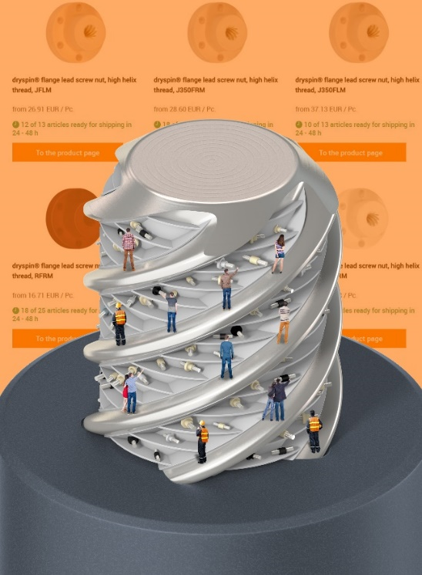
Picture PM4118-1
At the igus online shop, engineers can select from over 5,000 lead screw combinations. Also included: the new wear-resistant material iglidur J200 for lead screw nuts. (Source: igus GmbH)

